Git and Git Hub
GIT – Git is a distributed version control tool and it is used to track the changes of our source code/project.
In a case of 20 members of developers In a project we need GIT to know who, why, when make the changes and track changes we use version control tool
Two type of version control
Distributed version control tool – GIT
Centralized version control tool -Svm
Difference between Distributed version control and centralized version control
In Distributed version control we have copy of original data and it works faster than centralized version control
In centralized version control there is no copy of original data and it is directly save in server repository
What Is source code – In git source code means the program files(code) that are tracked and managed by git
GIT HUB- it Is a central repository/source code management tool to store the source code
Open Git
$ git init
$ ls -a
$git Config –list
To create user name- $ git config –global user.name “username”
To config email- $ git config –global user.email “email address”
To move files from untracking are to tracking area- $ git add .
To check the status- $ git status
To commit all the changes (to store the changes)- $ git commit -m “message” then enter and with $ git status we can see everything is clear
To see commit id- $ git log with this we can see all the changes
For every commit there will be commit id generated and it is unique
GIT HUB :- create a git hub account by visiting www.github.com and then move to git and $ git push
To create repositories in git hub click on new and add the repository name, owner is between description -first commit and select public then click on repository
Copy the url it showed of destination
There are two types of URLS
Https
Ssh
Always use ssh url
$ git remote add origin sshurl
To check url $ git remote -v
$ git push -u origin master
Then we need to create a key to github
$ ssh-keygen and enter then copy the path address and enter enter then key will be generated
$ cat path address and copy the key with out spaces, the go to git hub account settings and fine ssh and gpg keys. Then give title as my laptop and paste the key then enter. The it will ask for authentication code the enter the code
$ git push -u origin master then enter and you can see the files. Then go to Github and refresh the page and you can see all the files and we can share the email on slack with that link all team can access the files
If we deleted one file it gets deleted in local machine and you can see it on github, to update it check with $ git status there you can see the file name in deleted and $ git add . then $ got commit -m “Deleted file name” then enter and then $ git push -u origin master to see the file deleted in github and go to github and refresh and the file gets deleted.
If whatever changes we are making in local that will not reflect in github unless we use push command
If we create a file in github and change commit message to file on central repo and create it. Then we can see at git and check ls and there new file name will not visible as newfile is not created in localmachie gt. And we need to get that file in to local machine by this command $ git pull then ls and we can see the newfile name in localmachine git. And then push $ git push -u origin master to see the file
We have three commands git clone, git pull and git fetch. Now difference between this three commands.
Git clone is the command which helps us to central repo to local machine $ git clone ssh link then enter
Clone is download the all the changes. Git clone will download all the available data and it takes time and data
If suppose project is deleted from local system in this we can use git clone command to get it download
Git pull will pull the updated changes and we use it to save the data and time
To recover the deleted file we can use $ git revert <commit_id^c
To get the commit if $git log -4 there you can get the commit id:- $ get revert 05cdf
To move file to tracking area $ get add .
To move back file to untracking area $ git reset
Fork – we can copy file from one account to another account by using fork option
How to delete the project in github- got to settings scroll down then you can see delete this repository
Role of devops engineer – we will maintaining the repo, code will be develop by developers

Git and Git Hub 02

Branch –
Interview question (What is the branching strategy – we use release branch for production environment)
we are using Git flow branching strategy and we have 5 different branches
Release – what ever we stored in release and it is only used for production environment
Develop – which is used for Development/staging environment
Feature- is used for next updates
Hotfix - is used to fix the bugs of production server
Master/main – is used as a copy for Release branch
3 types of environment :-
- Development
- Staging/testing/UAT
- Production environment

To check the branches the command is - $ git branch –list
To create the branch the command is - $ git branch release
To switch from one branch to another branch the command is – $ git checkout release
While creating the new branch the files are transferred from previous branch to new branch
In Git hub we can create branch by creating new file under new branch name
How to merge code from different branches the command is – $ git merge branchname
We cannot merge specific file, we can commit the specific file by commit id- git log from the branch we want to get and the Command is- git cherry-pick commit id
PR – pull request
Pull request is used to merger two different branches
We can use pull request in git hub not in local machine. We can use merge in local machine
We can add invite users in git hub account by clicking on collaborators and click on add users and search with email address and send the invitation
Hot to change the message of the commit the command is- $ git commit –amend
To make the changes in the file we can send the file to stashing memory by the command- $ git stash
To get back the file from stashing memory to branch working directory- $ git stash pop
Merge Conflict:-
Merge conflict can be seen when we have two identical files with similar content
To merge different branches, if we have same file name in 2 branches and different codes in file we can use command- $ git merge branchname and with that we can make changes manually with vi file name after that we have to add file again and then commit it after that cat and check the data
To abort the merge operation the command is $ git merge –abort
To get help from merge the command is- $ git merge tool --help
to continue- $ git merge –continue
To download the specific branch name in local machine from Git hub the command is $ git clone -b branchname sshlink
How to ignore some personal files from git hub as we have added passwords in that file, create a file with vi secret file and add the passwords in that before tracking create a file with vi.gitignore and the secret file name then do git status we can see the secret file is ignored and add the file and commit it then push $ git push -u origin branch name then refresh in git hub and you check the output
If we are new to any project repository so we have README in github
Git pull and Git fetch
Git pull is to download the latest commands from git hub to local machine
Git fetch is to download the configuration details like origins, heads
To merge multiple commits into a single commit the command is- $ git rebase -i HEAD~number of commands we want to merge
How to get back the revert the commit- git commit id
Interview questions-
Branching strategy
Git pull and git fetch
Git merge and git rebase
Git cherry-pick
Merge Conflict

AWS CLOUD
Aws cloud – amazon web services
Azure cloud – Microsoft
GCP – google cloud
IBM cloud
Alibaba cloud

Cloud - In simple terms, the cloud means using the internet to store data and run software instead of using your own computer’s hard drive or local servers.
In aws or any cloud provider we have very common similarities- Technology, the ideology is almost same
Only change we can see is terminology might be different
What is the use of cloud- in any cloud computing this cloud computing works on 3 different parameters
IAAS – Infrastructure as a services: any provider who is providing us the infrastructure, ex. AWS: EC2, EBS, VPC
PAAS – platform as a services: On a particular infrastructure they will also provide tools to develop our application, ex – elastic bean stalk
SAAS- software as a services- it will have everything infrastructure as well as platform and some other platform, ex. Gmail, outlook
If every one has there own physical data centers why they are all using cloud service- in private data centers we need to maintain a team to secure the data daily basis to avoid this we are using cloud platforms
Aws cloud url – https://aws.amazon.com/console/
What is the difference between root user and IAM user- root user is nothing but one we have created account and we have complete access
Azure cloud – https://portal.azure.com/
In regions N.virgina the cloud platform is started
Region- region is a geographic location/collection of data
Availability zone: az is an data centre
Which region should we use ?
This depends on the client requirement and govt policies as well
Security groups in regions are different
AWS cost Management –
How can we control the cost/how to estimate the cost- we will use cost explorer to control the cost
Environments –
Development
Testing / staging
Production
How many aws account you are using- we are using 2 aws accounts, one is for development/staging activities and another is for production activities.
Security credentials-
MFA- Multi factor authentication
Benefit – extra layer of security
Software application or physical device

EC2
Ec2 in aws:
Ec2 : Elastic cloud compute where we can customize our servers based upon requirement
AMI: Amazon Machine images – Image of our operating system
Types of ec2 families -
VM in Azure:
VM: Virtual machine
With the help of this services we can provision one server for our environment
Launch ec2 – virtual servers in the cloud
Launch instance and provide the name for our identification as linux-all
- AMI: Amazon machine images – Image of our operating system
Quickstart AMIS- commonly used across different users
My AMIs – we have created for personal use or project use
AWS Marketplace AMIs – to get an ec2 to with a specific software, ex- ubuntu with apache software
Community AMIs – there will be a community to help each others
Instance type – Capacity of instance like we can check the properties like memory, hard disk,speed. For now we are taking t3 micro free for testing purpose
Kep pair login- any one connect to my instance that we have authentication to get connected with instance. There is no option to back up the key, be care full with the key do not edit it
Network settings – vpc a private network inside AWS
Subnet is a smaller network inside a vpc
Auto assign public ip- it will assign public ip to our instance with the help of public ip we are connecting to our instance
Fire wall (security group) – fire wall is a kind of software that help us to check for the routes and send the traffic towards. Security group always protect our ec2
Ssh works on port number 22
Use the same key pair for 10 instances and also use the security for 10 instances
Create a security group- provide the name and give the description
Inbound security group rules- ssh port number is 22, anywhere 0.0.0.0/0 and then we can provide the size of hard disk (ebs elastic block storage)
Volume type – HDD hard disk drive - slow
SSD- solid state drive - high
Magnetic drives
= IOPS- input and output speed of the particular process
Advanced details-
purchasing option – types of purchasing option
- On demand instances
- Reserved instances
- Spot instances
For example – on demand we are paying 100 rs per day – always available until we terminate the instance
Reserved instances we are paying 38 rs per day – 72% in price- if we purchase 10 instance for 6 months and we use for 3 days we have to pay for 6 months
Spot instances we are paying 10 rs per day -90% in price – there is a kind of 100 gb of ram and 100 core of cpu left at data centers in that case aws will provide it at cheap cost
Based upon left over hard ware they will provide some instance
Spot instances can be purchased based on bidding and it Is risky ( Bidding is a process where people or companies offer a price (a bid) to get something, and the best offer wins based on the rules.)
If some one offer more than we are paying they will provide a short notice and we get email that spot instance get terminate in 2 mins in that time we can transfer our data or else we will lose it
If we launch any instance that comes under on demand instance automatically
Stateless and state full applications :
Stateless means not storing any data
Stateful means storing data
Termination protection if we enable it no one can delete our instance
Tenancy- means rent
Shared tenancy- means all the users are working in one hardware
Dedicated host tenancy- no users can launch on this hardware starts
Userdata or bootstrapping
USER DATA – while launching instance we have to launch one application in that case we need to add the script in usedata
#!/bin/bash
Sudo yum -y install httpd
Echo “hello installing using userdata” >> /var/www/html/index.html
Sudo systemctl start httpd
For example if script is wrong or any mistakes then ec2 will ignore the script and just launch the instance
We can change instance type anytime- go to actions and select instance settings in that we can change the instance type
How to provide access to our team mate only for one project. As we have created 10 instances with one pem key so if we provide pem key access the team mate have access to 10 instances. In this case we can get the key from team by ssh keygen and we copy the key and paste it on our keys
Own AMIs- If we lost our pem key we cannot login to ec2 in this case we can create our own AMI for the instance as a backup. Then launch instance in that provide username and select my AMIs then rest all are same
Copy the pemkey and paste in on another new file. With the new file we cannot to the server ssh -I newfile name username@public ip
What is the use of keypair- a key pair is used for secure authentication when you connect to an instance.

VPC – Task 1
VPC in AWS:
A VPC (Virtual Private Cloud) is a logically isolated virtual network in AWS where you run your cloud resources, such as EC2 instances, databases, and load balancers.
While launching ec2 instance by default vpc id gets created
We have different different services in side our vpc which will help to assign one private ip to our instance which helps us to provide internet to our ec2
Services are
IGW: Internet gateway is responsible to provide inbound and outbound access
One internet gateway should attach to one VPC
RT: Route Table will define traffic routing rules
*ssh user login to internet gateway and If we have two ec2 our rt will decide where we connect
-SG: security group is to filter our traffic once the security group or firewalls are passed the request moves to ec2
NACL: network access control list
Security group and nacl both are fire walls that helps us to restrict unauthorized access to our ec2
Difference between NACL and SG – Nacl is working at the subnet level and try to restrict the acess at the subnet level and sg works at ec2 level and try to restrict the access at the ec2 level
Both are firewalls used to avoid unauthorized access
Nacl will work at subnet level
SC will work at ec2 level
By default everything is denied at sg lever
In nacl we can allow or deny the request
Nacl will work based on rule number
VPC – vpc range or vpc public ip is 172.31.0.0/16 -> CIDR Range
CIDR- classless inter domain range -> for any vpc we need configure one CIDR range and ip address will going to assin is under cidr range
For any ip address we have 5 different classeless
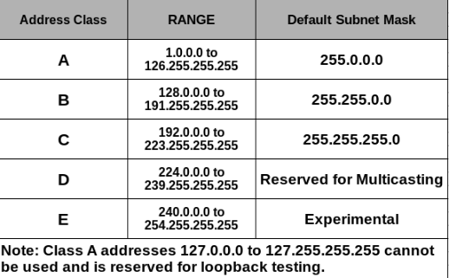
Range of ip is 1-255
Class A ip address range is 1 – 126
Class B ip address range is 128-191
Class B and Class C use for public purposes and we are using only B and C
Remaining A,D and E is for testing purpose
172.31.0.0 is Ipv4 (internet protocol version 4)
Ipv6 will be in alphabetic version like 2001.db8.333.4444.
The range of ipv6 is very high comparing to ipv4
172.31.0.0/16 what is /16:- /16 is subnet masking
Subnet masking will help us to classify the ip addresses
172 :8bts
168:8bts
0:8bts
0:8bts
Total : 32 bits
172.168.0.0/32 -> max in aws and azure
172.168.0.0/16->min in aws
172.168.0.0/16-> min in azure
172.168.0.0/16 = 32
32-16=16, whatever subnet masking address assign we need to subtract with 32
2power16 -> 2^16 = 65,536 are been assigned to this particular range 172.168.0.0/16
Why are we adding this with 2^-> any machine try to communicate in terms of binary language for the output like 1001000110101 it is in 2
172.168.0.0/16 = 65,536 ip addresses are assigns
DHCP – dynamic host control protocol will assign the ip address
Suppose if we have 192.168.0.0/24 we need to find how many ip address are assign
Vpc : 192.168.0.0/24
32-24= 8
2 power 8-> 2^8 = 256 ip address
192.168.0.0-> first ip
192.168.0.1
192.168.0.2
.
.
.
192.168.0.255 -> last ip
Inside VPC we have subnets
Subnets is nothing but smaller portion of Vpc.
Two types of subnets-
public subnet- having access to internet
Private subnet – no internet access
Ip addresses wont overlap
Vpc : 192.168.0.0/24 – 256 ip address
pub-subnet: 192.168.0.0/28 16 ip address
192.168.0.1
192.168.0.2
192.168.0.3 to
192.168.0.15
Pri-sub: 192.168.0.16/28 16 ip address
192.168.0.17 to
192.168.0.31
As per our subnets 16 ip address are created and it showing 11 ip address are in the subnets in ec2 and remaining 5 ip address will reserved by AWS for internal use like backup
If we have 256 ip address we can use 251 ip address
Aws will reserved the 5 ip address in 16 ip address the first 4 and last ip will reserved by aws
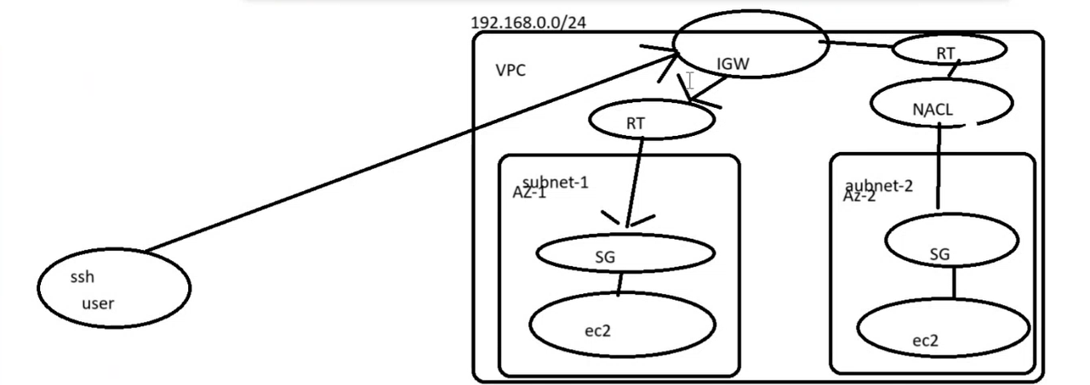
Create a internet gate way and attach vpc
If we disable NACL - NACL is the firewall which blocks the request, it will work based up on the rule number
If user don’t have internet access to private subnet, user can cannot to server with public subnet to private subnate, by connecting ssh with public ip and add the key to public server vi key name and enter the key also provide the permission and connect with private ip it is used for internal communication
In one region only 5 vpcs we can create
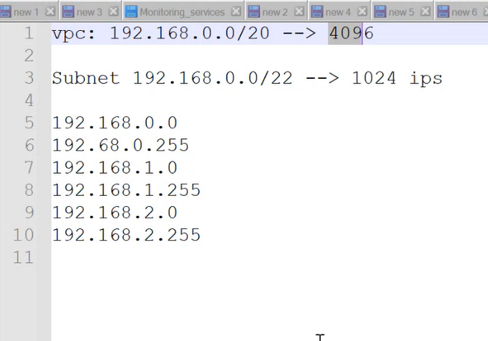
we have fluctuations in last 2
VPC -Task 02
Nat Gateway/Nat instance :
NAT : Network address translation (this service in aws will help us to provide internet access to the access instances which are in the private
NAT gateway/Instance are used to provide internet access to instance in private subnet.
Nat gateway will always in public server
NAT GATEWAY : aws provided service, maintained and managed by aws itself.
NAT Instance: our regular ec2 with NAT configuration, we are responsible for the maintanence and uptime
Why do we need NAT gateway ; we don’t want to expose our application that is the reason we need nat gateway
Difference between IGW and NAT gateway:
IGW is used for inbound and outbound access.
NAT is used for outbound access.
-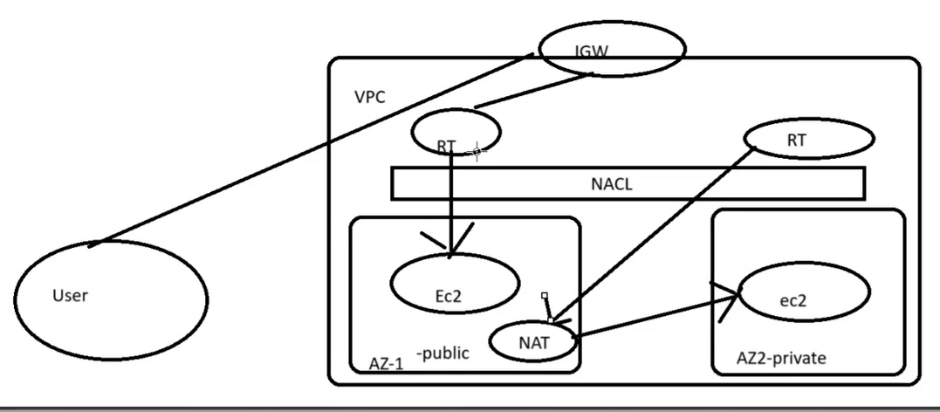
Elastic Ip: elastic ip are nothing but static of fixed ip address
S3 is one of the storage available in aws
Cloud watch is one monitoring service available in aws which will help us to monitor our applications
IAM is one servce– identity access management. Iam will help us to provide different level of access to different users
Role- whenever you want to communicate from one service to another service. (flow log to cloud watch)
VPC flowlogs : A VPC Flow Log is a feature in Amazon Web Services (AWS) that records network traffic metadata going to and from resources in a Virtual Private Cloud (VPC)

VPC peerings : VPC Peering in Amazon Web Services (AWS) is a way to connect two Virtual Private Clouds (VPCs) so that resources in each VPC can communicate with each other privately using internal IP addresses, just like they were on the same network — without traversing the public Internet.
Vpc peering will help us to communicate between multiple vpc in same regions different regions and different aws account
No two CIDR range should be overlapped
Peering will established bidirectional communication
Billing will be charged based on transferring of data
Vpc-1: 192.168.0.0/24
Vpc-2:172.168.0.0/24
connections between one region to another region
Launch one ec2 to another region. We cannot another server with public ip to connect it private we need to launch another ec2 in same region and both are public
Same region ec2 will connect with private ip because we are in same vpc.
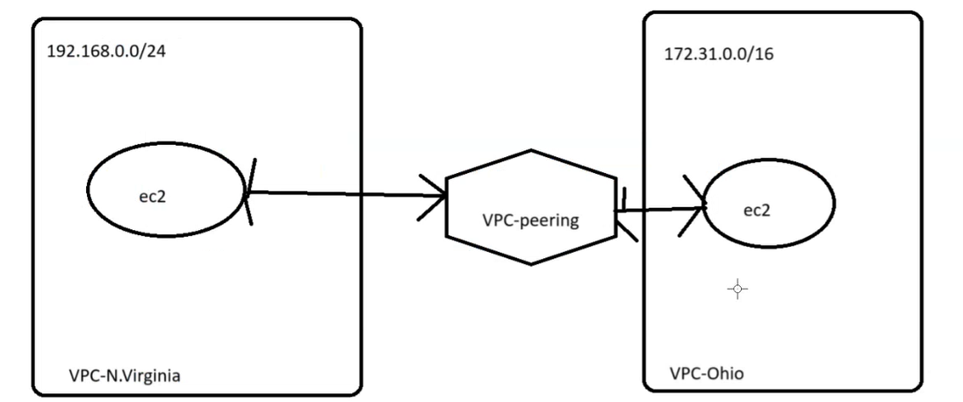
If we have 6 vpcs how many connections are required—15 connections are required formula is n(n-1)/2

VPC-TASK 03
VPC ENDPOINT: VPC Endpoint service will help us to communicate with aws services without internet
Means the communication will be private and will be with in VPC.
How to identify a subnet is public or private with the help of route table we can find
Aws configure- go to s3 and delete if any access key available and now creating access key
aw s3 ls to check the bucket
Now connect ssh with public key and connect with bastin copy the key pem and create a new file and paste the key and give the permission 400 and login with private ec2
Create a endpoint and attach it to routing table of private subnet
Go to vpc and click on end point and create a end point by selecting aws service and type s3 in services search and you will see the categories of service and select amazonaws s3
For every ec2 instance we are getting one network interfaces getting created
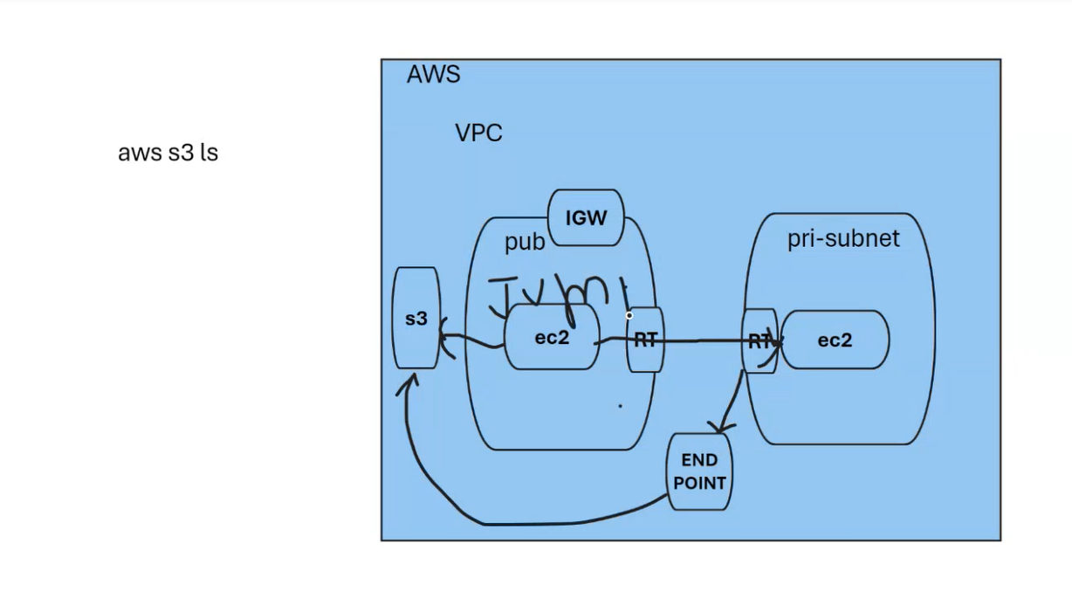
TRANSIT GATEWAY: AWS transit gateway will help you to connect 100 of vpc on cloud and on premises
It will create a hub and spoke design to connect multiple vpc’s
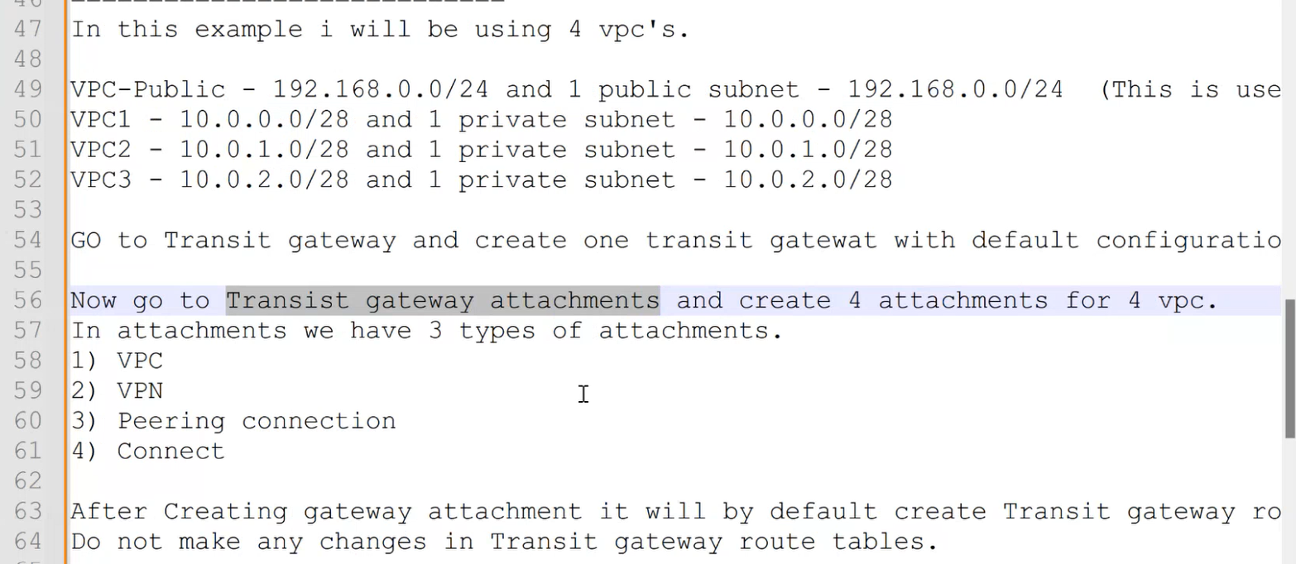
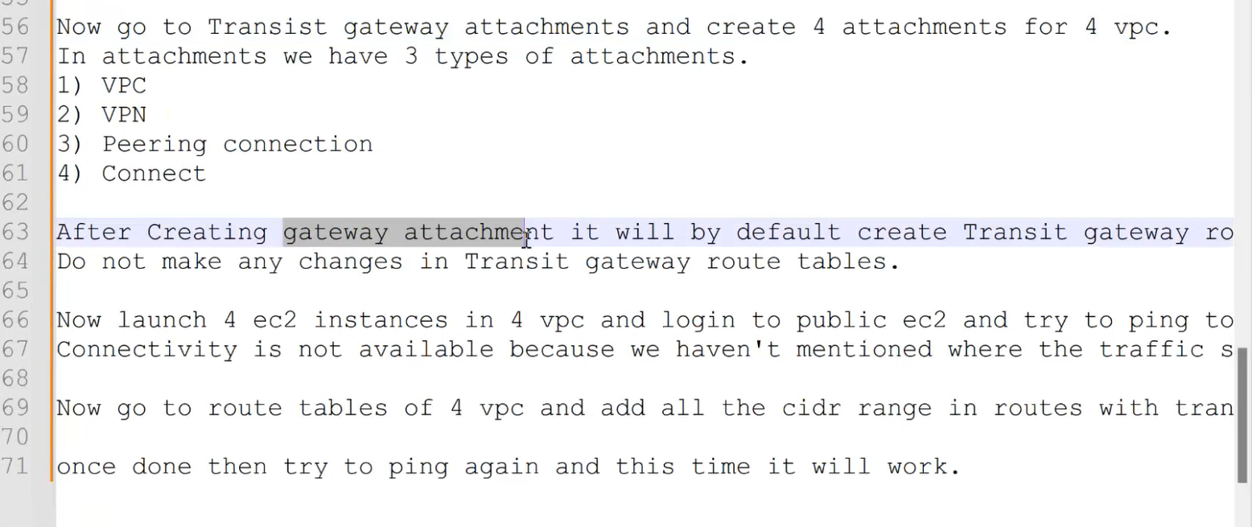

IAM
IAM- Identity access management
helps us to create users
From root account we can create user to login to service and for testing we are attaching amazons3readonlyservice and provide the user name and password to user to login
S3 readonlyservice is for training
Bucket name should b unique
Groups: groups are required because they make access control scalable, manageable, and secure.
Whatever policy attach to the group it will applicable for all users because users are added in the group
Policy : policy defines the permissions of the IAM identity, like amazons3
Types of policies :
Identity based policies:
- Inline policy- a policy create for a single user, if we delete the user the policy gets deleted
- An inline policy is a policy created for a single IAM identity ( a user, group or role)
- Inline policies maintain a strict one-to-one relationship between a policy and a identity and they are deleted when we delete the policy
Managed policies:
Aws managed policies -managed policies that are created and managed by AWS
Customer managed policies – managed policies that you create and manage in your AWS account. Customer managed policies provide more precise control over your policies than AWS managed policies
ROLE- roles are attach to specific resources and this are not used for specific users
IAM role is an identity within your AWS
If we want to communicate to another service with same account or another we need role
How to create owned AMI -
snapshot is nothing but certain point of capturing
EBS volumes – Elastic block storage are like hardware’s in our ec2
We cannot use one volume to multiple EC2 instances
We can use multiple volume to one EC2 instances

S3
S3 means simple storage service and it is a global service there is no specific region
s3 bucket is a region specific- when we are creating a bucket we can pass the region
s3 is used for fixed objects- if we need to make any changes we need to download and make the changes
s3 bucket name should be unique globally
In aws we have 3 different storages
EBS- we can connect multiple ebs to single ec2 and we cannot connect multiple ec2 to single ebs
S3- we can transfer data from multiple to ec2 to s3 from different region
EFS- (elastic file system)- this can also be used used across different ec2 in same region
Object means file
Create a bucket and give permissions and upload a file and mark as public and click on the file you will get the object url copy url and paste it on browser and you will see the file data
Acl at object level and bucket policy at bucket level
We cannot mark as public manually to all files to make it automatically we need to add policy in Json format
To change the version of the file we need to enable the bucket version
Default s3 storage class- Storage class
Standard IA
S3 glacier
Deep archive glacier
Each class have its own cost structure - in order to reduce the cost we move them to one storage class to another
We can also use our s3 bucket to host a website- go properties and you enable static website hosting
What is bucket policy – bucket policy specify what actions are allowed or denied for which principles on the bucket that the bucket policy is attached to
S3, cloud front, Aws ACM and ROUTE 53
( Why did we use s3 in project- we have used s3 to store vpc flow logs, images related to our application and we have used s3 to deploy one static website.)
Cloud front- it helps us to improve the performance and reduce the latency
Route 53- it will be used to configure the domain name servers
We have 2 protocol- http work on port 80 and https work on port 443
ACM- amazon certificate manager service
SSL certificates - secure socket layer
ssl is extra layer of security which will ensure a trust between the end user and our website(client) that this particular website is trusted, the data whatever transmitted it can’t be still any one it is a secure connection ( if we search http://google.com in website and it automatically apple ssl and it opens with https://google.com)
Route53- 53 is the port number for the DNS service
DNS- domain name server
We need to create a Domain in Godaddy and purchase the domain for 1 year mahmood07868.info and we have domain in godaddy and we need to tell our route53 that our domain in godaddy.
With the help of nameserver(NS) we can say our route 53 that our domain in godaddy
ns-1426.awsdns-50.org
ns-654.awsdns-17.net
ns-198.awsdns-24.com
ns-1723.awsdns-23.co.uk
Go to godaddy and click on manage domain then click on DNS and click on nameservers and change nameservers and paste the above 4 servers in the own server and save it.
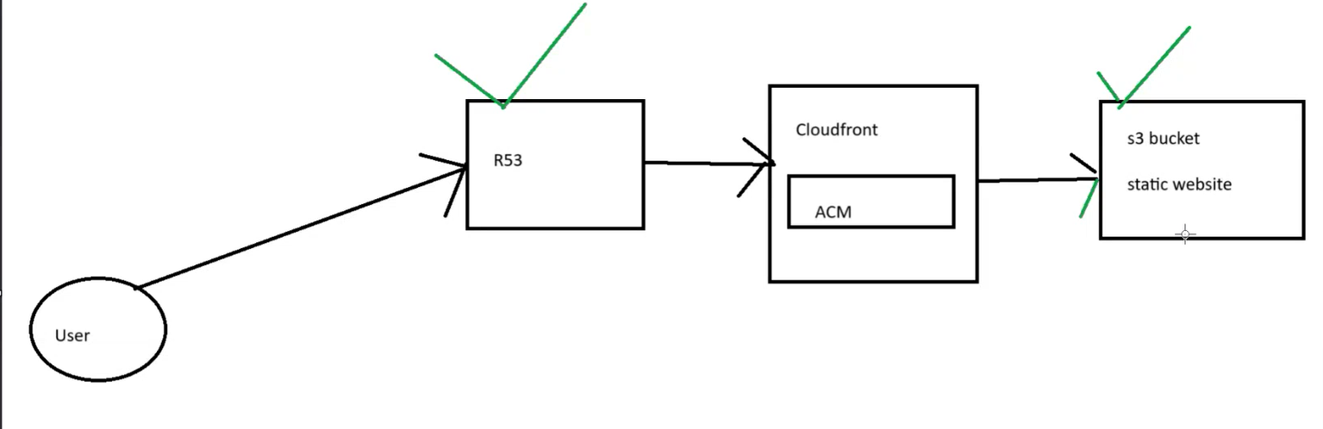
Cloud front- it helps us to improve the performance of website and it will secure our application
Region, Availability zone, edge locations.
edge locations are used in cloud front and it store our application in different different edge location via cache, cloud front is used for distributed network
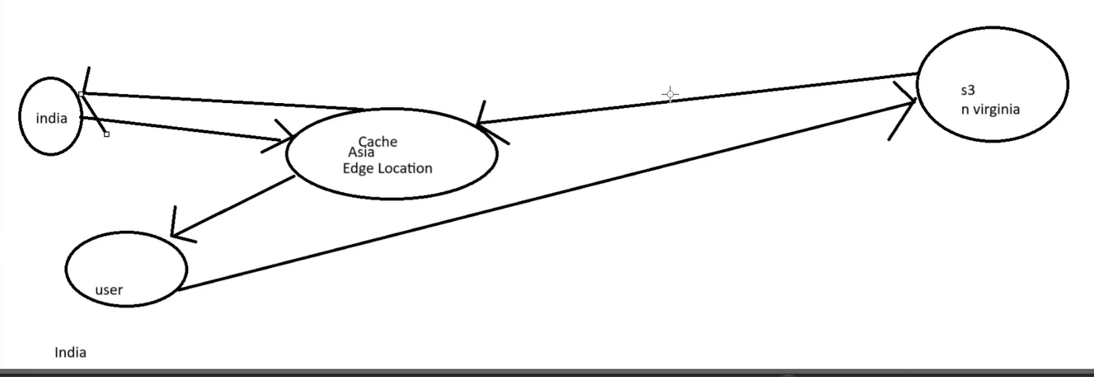
Open cloud front distribution and create distribution and provide origin domain to provide domain origin copy the url from properties of domain bucket in settings use north America,Europe,asia and create then copy the DNS and paste it on browser and now s3 bucket is added to cloud front and we can see s3 bucket from cloud front distribution id
Now we need to add the cloud front to route 53
Go to route 53 and click on records and record type A and we have an option called Alias
Alias will help us to directly point to the resources and click on alias and select cloud front distribution

Cloud Watch and Cloud Trial
Cloud trial- this service will helps us to track the activities of aws account
Cloud trial is a service that enables governance, compliance, operational auditing and risk auditing of our aws account
It records all the activities done by user,roles and aws service
These recorded sessions are called as Events
Cloud Trail is enabled on your AWS account when you create it
View events in Event History, where you can view, search, and download the past 90 days of activity in your AWS account
Aws is not charging anything for these default event creating
Type of Log events:
Management Events
Capture management operations performed on aws resources
Free of cost for one management event by aws
Management events will be created by default
Ex- who signed in at what time and other api calls execute on resources
First management event is free and if we create another management it will charge
Data Events
Log the resource operations performed on or with in a resource
Ex- when user uploaded, deleted and downloaded files in s3.
The log printed after 6-7 hours
Insight Events
Identify unusual activity, errors or user behavior in your account
Ex- Unauthorized API calls indicate some one tried to perform an action in your aws account that they did not have permission to carry out
SNS – simple notification service this helps us to send out the notification alert to the user
Cloud Watch-
Cloud watch is a service used to monitor your AWS resources and application that you run on AWS in real time,
cloud watch is used to collect and tract metrices that are measure resources and applications
It displays the metrices automatically about every Aws service that you choose
you can create the dashboard to display the metrics about your custom applications and also display the metrics of custom collections that you choose
You can also create an alarm to watch metrics
For eample- you can monitor CPU usage, disk read and disk writes of amazon Ec2 instance
It can also be used stop the instance to save money
More than 70% of cpu utilization is not good for us, our system will very slow- to avoid such cases we need to create a monitoring alert
What is Metric- Metrics are a measurement at a point in time for the system
Types of Metrics:
Cpu utilization
DiskReadOps
DiskWriteOps
DiskWriteBytes
NetworkIn and NetworkOut
NetworkPacketsIn and NetworkPacketsOut
MetadataNoToken
Cloud watch agents are installed on our ec2
Dashboard – dashboard is nothing but graphical user presentation, the monitoring part is the dashboard
We can create dashboard and add the name as cpu utilization and select wedget as numeric and copy instance id and paste it in pre-instance metric
What is alarm-
Cloud watch alarm is used to monitor a single cloud watch
metric or the result of Match expression using cloud watch metrics.
Also, it sends out a notification based on the threshold we set for each service in cloud watch alarm
Types of Alarms.
There are 3 alarm states:
Ok – With in Threshold
ALARM – Crossed Threshold
INSUFFICIENT_DATA – Metric not available/ Missing data (Good, Bad, Ignore, Missing)
For each service we need to create rule to communicate and we can create a rule to terminate the ec2 after 3 alarms when cpu utilization is 70% above
Monitor a specific service and send the metric to cloud watch

Auto Scaling Groups
If our instance in t2.micro and it supports 100 users and we have 100 users login to instance the server will be low in this case we have ASG
ASG is used to scale up and scale down instances based on certain metrics
It automatically add one new instance if number users or requests are high
Example: If CPU Utilization is more than 70 for 5 mins then new instances will be launched using ASG.
Scaling options:
Vertical scaling – we add more power to existing instances
If we are in t2.micro then we can extend to t2.medium
To the same instance we are changing the instance type by adding more power
With the auto scaling we can make sure our application is highly available

Horizontal scaling- Adding new instances to the environment
if we have 1 ec2 instance then it will add 1 new ec2 instance
To understand where aws needs to pick all this, if we want to use auto sacling we need to configure one template from where all the configuration needs to be picked up
ASG will work based on launch configuration and launch templates.
Launch template is something we can have multiple versions on same template file with some minor changes and we can edit the same template and aws is recommended
We have 3 types of states in ASG.
Minimum : 1 – means atleast 1 instance should be available, if minimum is 1 suppose our instance is deleted then auto scaling will create a instance
Always make sure that desired status will higher than minimum
Desired : 2
Maximum : 5
Desired should be always greater than minimum
Launch Template and launch configurations
Both launch template and launch configurations are similar
Launch template support multiple versions of templates.
We can edit or override some parameters in launch template and it is recommended by aws
Launch configurations are not edited and if we want to update any thing then we need to create new launch configuration again
Not recommended by aws.

Load Balancer
Elastic load balancer (ELB)- No of users who are trying to access our servers the load balancer help us to redirect
Why are we deploying multiple subnets -for high availability of applications we will use multiple regions
If we have any 5 servers and we cannot share all the 5 servers to users in this case our load balancer have DNS name and it distributes the load
if some has deleted one server and we have only one server our load balancer will manage the request it wont sent to deleted server
load balancer will run the health check if server is alive it send the request or else it will ignore the ec2 server
Elastic ip have only one load balancer
DNS- Domain name server
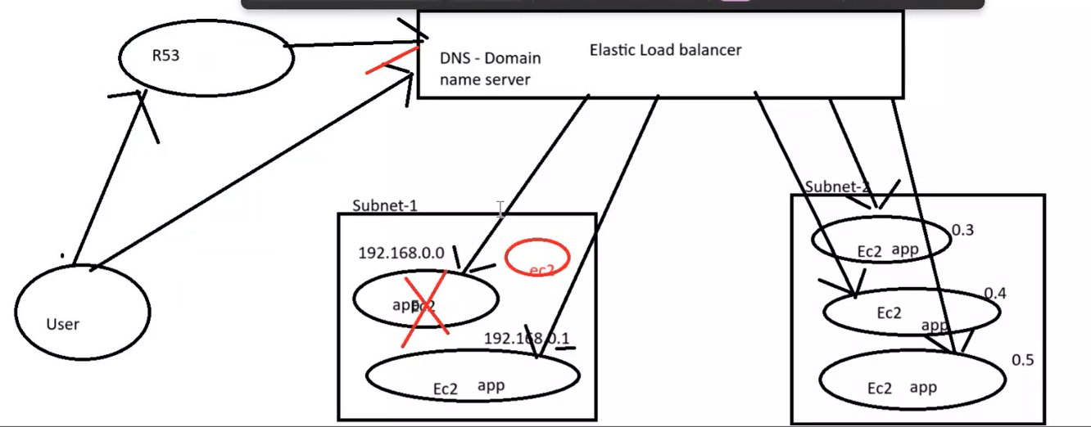
Types of load balancer:
Classic load balancer :-
Protocols- http 80, https 443, tcp 80 and ssl 443
If we want to use classic load balancer then we will have equal servers in both the availability regions
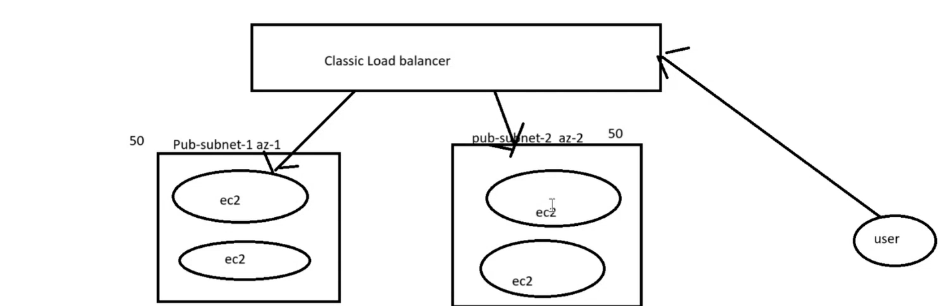
Internet facing is public and internal for private
Load balancer is always in public subnet if we want to explore out of world, and there is no use of private
This will follow round robin algorithm
If we have 5 applications we need to create 5 load balancer to manage the traffic
Application load balancer:-
Protocol- http and https
Any request that provide path with that path the request redirected
if user is not providing any path in this we have option of default path and that we need to create a target group the default path like home page
we can configure different rules, listeners and it will based on path prefix
When should be use application load balancer- if we are aware of traffic accessing our application and our application is working on https protocol’s then we can use the application load balancer
we can create 5 applications in one load balancer and we can manage the traffic
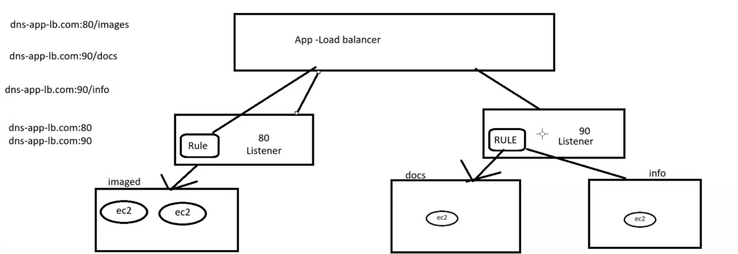
Application load balancer works on layer 7 i.e. application layer of osi model
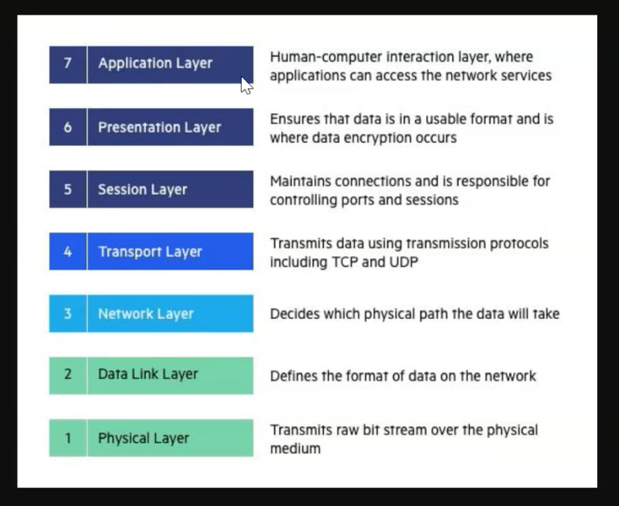
Network load balancer :
Protocol : tcp and udp
Network load balancer works on layer 4 i.e. transport layer of osi model
we can configure different rules, listeners and it will based on path prefix
We can configure one elastic ip, which is not possible in application layer
when we should use network load balancer- if we are expecting sudden spiked in traffic then network load balncer something which will help us to manage the traffic and application will be accessible to end users
(Live streaming applications managed by network load balancer)
Tcp and udp – udp is work faster than tcp and tcp is more secure
Which load balancer you guys were using – we are using application load balancer
Load balancer access logs- with the help of access logs we can get the complete detail monitoring who is trying to access our load balancer
IAM role – role will help us to add some permissions to communicate from one service to another
What is the difference between app lb and network lb -
Application load balancer:-
Protocol- http and https
Application load balancer works on layer 7 i.e. application layer of osi model
we can configure different rules, listeners and it will based on path prefix
When should be use application load balancer- if we are aware of traffic accessing our
application and our application is working on https protocol’s then we can use the application load balancer
we can create 5 applications in one load balancer and we can manage the traffic
Network load balancer :
Protocol : tcp and udp
Network load balancer works on layer 4 i.e. transport layer of osi model
we can configure different rules, listeners and it will based on path prefix
We can configure one elastic ip, which is not possible in application layer
when we should use network load balancer- if we are expecting sudden spiked in traffic then network load balncer something which will help us to manage the traffic and application will be accessible to end users

